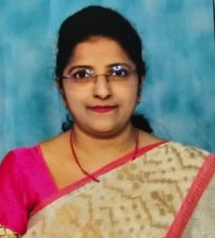**MURARI SHANTHI HAM**

Lecturer in English

Government Degree College (Men) Srikakulam.

DOB: 25-03-1973

# Education

M.A ( English) from Osmania University 1998

# ACADEMIC CAREER

Worked as Junior Lecturer 1998 - 2010.

Promoted as Degree College Lecturer since 2010.

Total Work experience of 24 Years

# SEMINARS/WORKSHOPS

Infosys Project Genesis Programme ( TTT ) from 03-08-2011 to 12-08-2011.

English Language Fellow Programme ( ELF ) from 17-01-2012 to 23-01-2012 at Hyderabad.

A.P. State Lecturers Retraining Programme ( Follow -up- Workshop) on 26-04-2012.

Attended 5 day FDP program conducted by CCE from 31-08-2020 to 04-09-2020.